Beginner Advisory Update Procedure:

Addling Spreadsheets & Alerts to Chimp campaign info:
GETTING the updated spreadsheet to CHIMP
- Update all trades done for the day as appropriate
- Add any commentary as needed
- Downloading the sheet in the correct format:
    - From the spreadsheet - Highlight columns A thru K
- 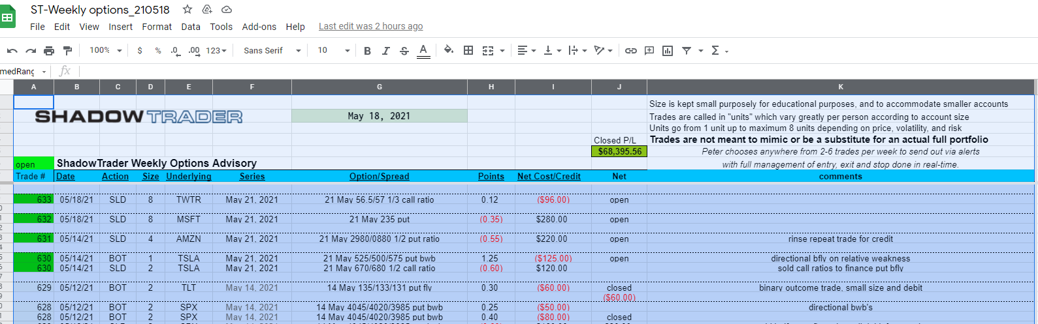
      - Click “FILE”
        - Hover over “Download” and click “PDF document”
        - 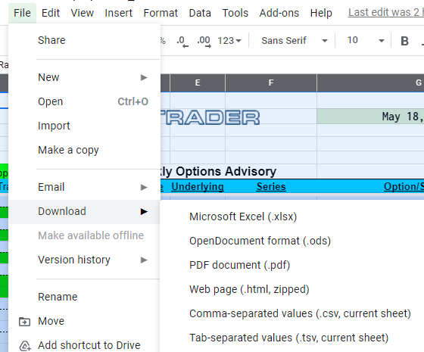
        - On the right below Cancel / Export, click “Current Sheet”
        - Choose and click “Selected cells (A:K)”
        - NOW click EXPORT box above.
        - 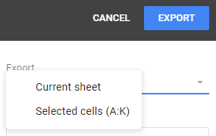
        - This will download the pdf to your download directory

GETTING alerts from the rooms to CHIMP
- From the PTR room
  - To the right of “Post Alerts” is a GEAR
    - Click
      - Choose the disk drive icon – this downloads all alerts
      - 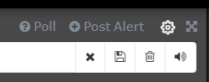
  - Open the “alert…” download – should open in Microsoft text editor
- Scroll to the current date
  - Copy all alerts
- Open “Alert Daily Sheet” – copy was sent via email
  - Under the correct date– paste the copied alerts
  - Add a space between each date time entry
  - IF there is a link for any alert – go to the end of that line and hit the space bar
    - This will add the hyper-link needed for Chimp
- Open Chimp campaign for the advisory – draft
  - Click “Edit Design”
- Click the box for alerts editing
- From “Alert Daily” sheet copy and paste that day’s alerts.
  - Click “save”
- ADD any commentary either directly or by pasting from some other text document
- Open the box below commentary to update the spreadsheet link
  - Highlight CLICK HERE
  - Click the link icon in the tools at the top right
  - Dialog box “Insert or Edit Link appears
    - Click the drop down “Link to” box and choose FILE
  - Click UPLOAD ( upper right)
  - Open the download directory and DOUBLE CLICK the spreadsheet pdf
    - (for the correct advisory)
  - Click “INSERT’ when the next dialogue box appears
  - IMPORTANT: click your cursor anywhere in the white area of this box
  - Click Save & Close
The Chimp campaign is now ready to be previewed / edited and finally sent
This can be accomplished multiple ways
The best I found was to click CONTINUE and then click on the Content area text box for a preview
This will give you a look at the email to be sent as well as all of the parameters for the header.
When done reviewing (previewing) click the “X” in the upper right
If you need to edit, go into the appropriate section and make the edits
If it is okay the click send

